Establish a new directory, populate it with script files, initiate an empty repository on GitHub, convert the local directory into a Git repository, and link it to GitHub for pushing the code into the repository.

Solution:-

Launched an Instance at AWS and Installed git

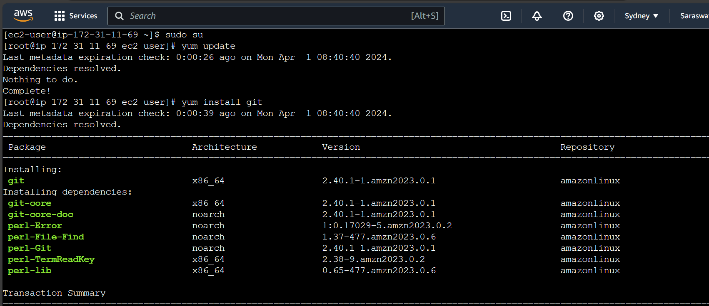

Created a new directory named as git and created script file named as file.txt

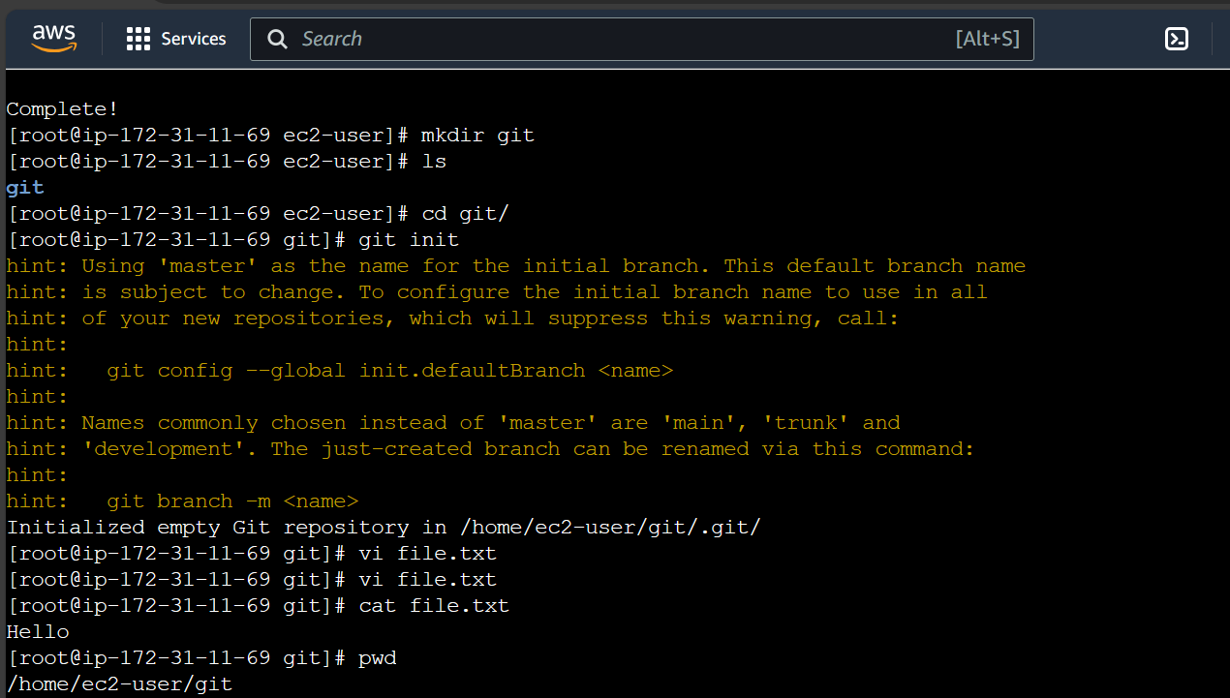

Created an empty repository named as **Task-Day-3---VCS---Git-GitHub**

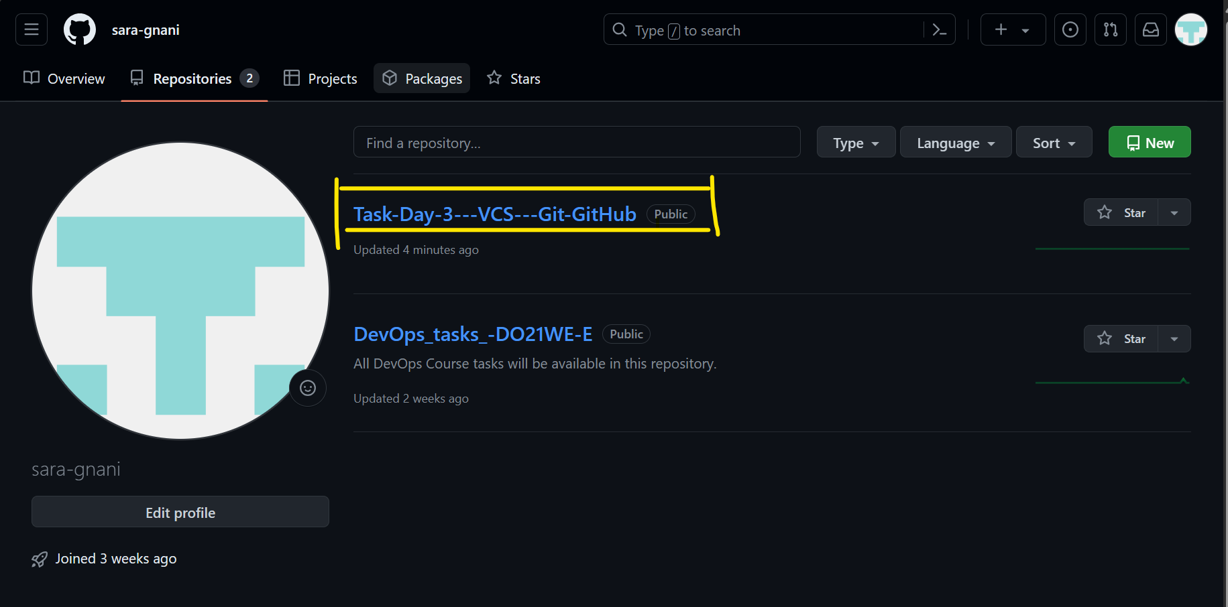

Generated Token

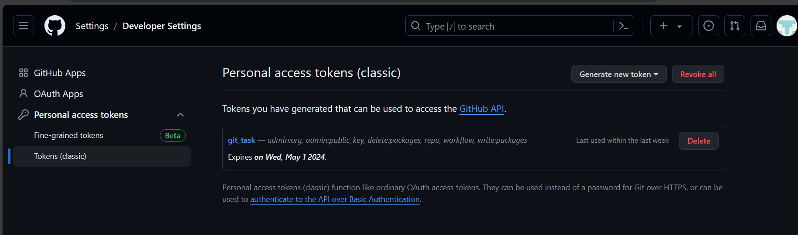

Linked git and pushed the file into git repository

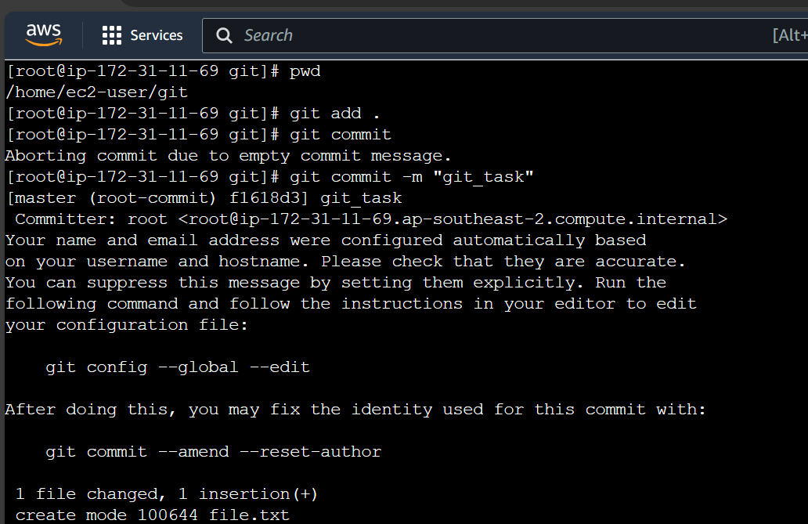

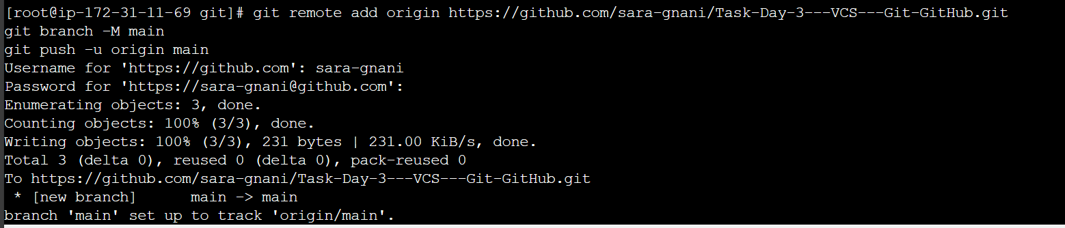

Below you see the file.txt has been moved into **Task-Day-3---VCS---Git-GitHub** repository

